Step 1: Getting Around
Metro Rail:
Opens: M-F @ 5 a.m.; S+S @ 7 a.m.
Closes: Sun-Th @ Midnight; F+Sat @ 3 a.m.

For all specific station times, go to wmata.com/rail/schedules.cfm

SmartTrip Cards:
SmartTrip cards allow easier metro access, cheaper fares, and weekly or monthly reloadable pass options along with a separate declining balance.

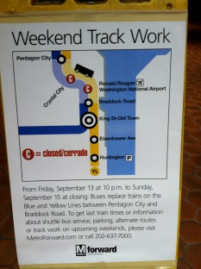
For more information see: wmata.com/fares/smartrip/

Track Work:
Keep your eyes open for track work, which may affect your commute.
When a portion of a line is down, FREE shuttle busses are offered to continue the rout.

Metro Bus:
Along with the metro rail, a bus system is also used to get to other locations.
To use the bus system, exact change is needed to board, or you may use your
SmartTrip card and your fare will be taken out of your declining balance.

For more information, visit: wmata.com/bus/

Taxis:
If you don’t want to wait for a bus or train, a taxi may be a viable option.
Many only take cash, so having an extra $20 is useful for emergencies.

Taxi Transport Service: 202.398.0500
Follow those before you…
Greg
Early on during my time at Comcast SportsNet I was put in charge of cutting and ordering highlights for a top-5 list. Having a week’s worth of highlights in front of me, editing finished, and a few hours left on my shift with nothing to do (don’t worry, I asked), I cut up a highlight package of my own. On my way out I showed it to my supervisor as a passing thought. After viewing the clip, he loved it and not only uploaded it to the website (front page mind you), but encouraged me to make one every week.
Shortly after, I became the go-to for video editing. A co-worker once framed my skills by saying, “I can make it work, but you can make it sparkle.”

Shannon
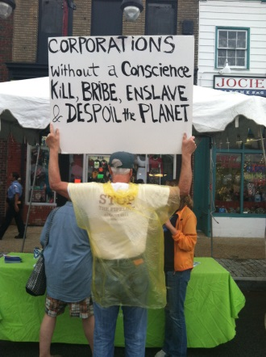
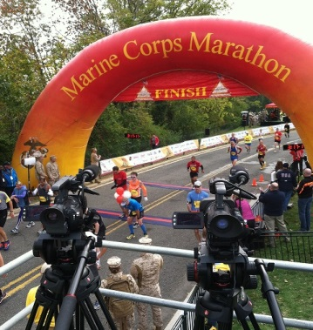
I worked at the Attorney General’s Office for the District of Columbia (OAG) in the Fall of 2013. One of my issues when I started was not getting enough work to keep me busy throughout the day. However, with persistence the lawyers in my section gave me projects that required time and could not be conquered in one workday. The key to receiving more meaningful projects is to keep asking for work and being grateful of the work you do get, even if it is just scanning papers. During, my first month at the OAG I easily scanned about 1,000 pieces of paper but at the end of my experience I was going to deposition preparations, and observing trials. Once you can prove you know how to do the easy stuff, no one will be afraid to give you difficult tasks.
My website is scmccullough.weebly.com
for more adventures about DC!
4 Steps to Surviving D.C.

By: Greg Lachapelle
And
Shannon McCullough

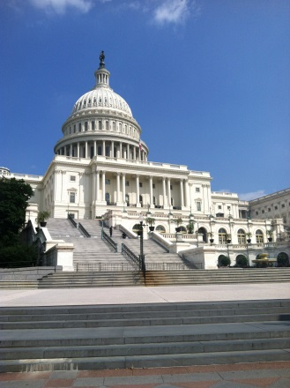
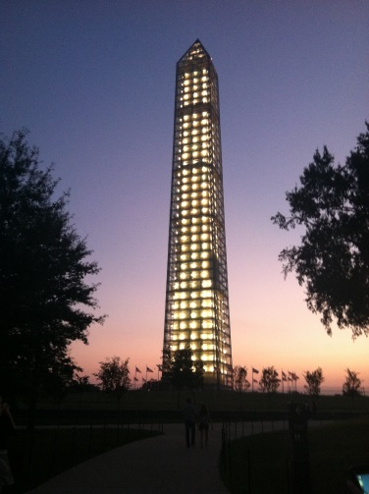

Step 2: The Internship
Dos
- Practice run of how to get to your internship.
- Ask Questions!
- Get a task description of your daily duties or an over lying project.
- Stay Busy
- Get an office tour
- Smile
- Share your interests
- Volunteer!
- Have your own business cards
AND
- Ask for other people’s business cards

Don’t do this… do that…!!
- Don’t complain about copying and filing
  - Do these tasks quickly and effectively. It will be noticed and you should be given projects with more substance.
- Don’t expect special treatment
  - Do expect to be shown the ropes and explain when you don’t know certain skills.
  - Don’t ask for a job or recommendation the first day.
  - Do work hard so they offer you a job or recommendation when you leave
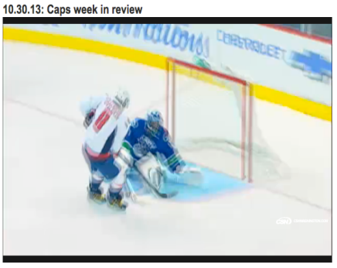

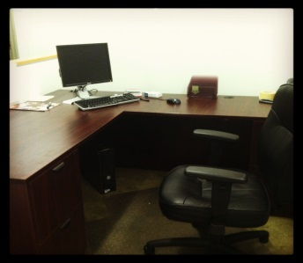
Step 3: Eating Out

Below are some of the best places tried and true to eat at in D.C.
- Ben’s Chili Bowl-
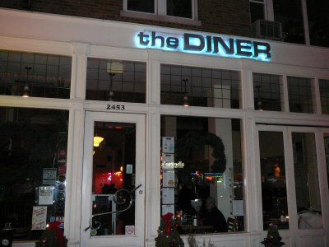
Bill Cosby’s favorite restaurant is found on U-street right off the metro.
- The Diner-
Found on Adam’s Morgan St. Is open 24/7 and has the best pancakes.
- Coffee Alley-
In a well-lit alley in China town right next to the Verizon center. Great coffee!

Eating in
However, since it is not possible to eat out for every meal that you have in D.C. packing a lunch is essential. In Crystal City there are several grocery stores within walking distance.
- Costco
- Allows you to buy in bulk and carry them home in the shopping carts.

- Harris Teeter
- Allows you to have fresh produce for meals with great weekly sales.

Step 4: Staying Active
Networking opportunities are everywhere. Remember, it is always an opportunity to network. Simply getting out and talking to people can yield great results.

The Washington Post offers weekly overviews of events going on in the DC area. From Oktoberfest to photography tours, it’s easy to get out and get involved.

Used by “students, professionals, and lifelong learners,” you can easily find think tank events to attend addressing the topics you care about for just a pay-what-you-want monthly fee. Visit dc.linktank.com for more.
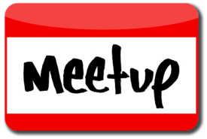
A great free tool used to meet up with groups within your active interests. Whether it be recreation, sightseeing, or relaxation you’re looking for, there’s a group that’s looking for it too.

Group from Wii volunteering at Bread for the City
